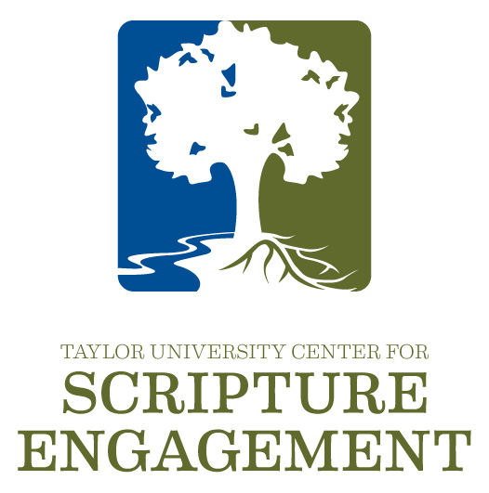

Would you like to have a workshop at your church or ministry?

If you think the Center can be of some service to your ministry, we would love to partner with you to design a workshop, series of workshops, or whatever may fit your specific needs.

Training sessions are highly interactive, developing both the theology and practice of Scripture engagement and can be designed for:

- ministry leaders (training you to teach your people)
- specific ministry groups (youth, young adults, adults)
- whole congregations
- a community of congregations (two to three different churches/ministries)

The cost of the workshop depends on the number of participants, travel expenses, and length of the training.

If you would like to have a follow-up discussion with Dr. Collins, you can reach him at:

- Phone: (765) 998-4670
- Email: phcollins@taylor.edu
- Or fill in the information below and email this form to: Noelle Brennan at nlbrennan@taylor.edu.

Name of Ministry Leader:
Name of Church/Ministry/Title:
Phone: |  |  |  |  | Email:
Type of Training:

